**RestDemo.java**

**package** com.example.demo;

**import** org.springframework.web.bind.annotation.GetMapping;

**import** org.springframework.web.bind.annotation.RestController;

@RestController

**public** **class** Restdemo {

@GetMapping("/myurl")

**public** String sayHello()

{

System.***out***.println("sayHello....");

**return** "Hi how are you";

}

//Retrive person info using

@GetMapping("/personinfo")

**public** Person getDummyPerson()

{

Person p=**new** Person();

p.setName("Ram");

p.setEmail("Ram@gmail.com");

p.setAddress("Delhi");

**return** p;

}

}

**Person.java**

**package** com.example.demo;

**public** **class** Person {

**private** String name;

**private** String email;

**private** String address;

**public** String getName() {

**return** name;

}

**public** **void** setName(String name) {

**this**.name = name;

}

**public** String getEmail() {

**return** email;

}

**public** **void** setEmail(String email) {

**this**.email = email;

}

**public** String getAddress() {

**return** address;

}

**public** **void** setAddress(String address) {

**this**.address = address;

}

}

**PersonServices.java**

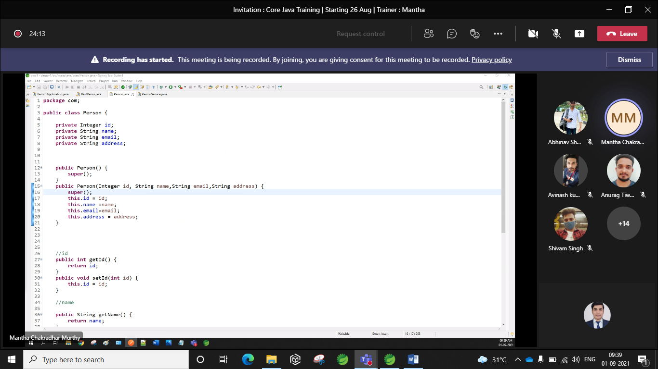

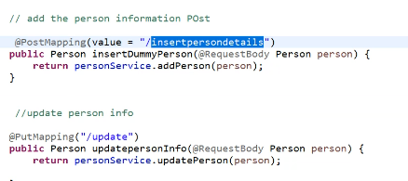

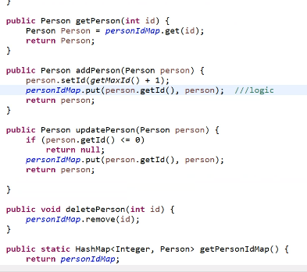

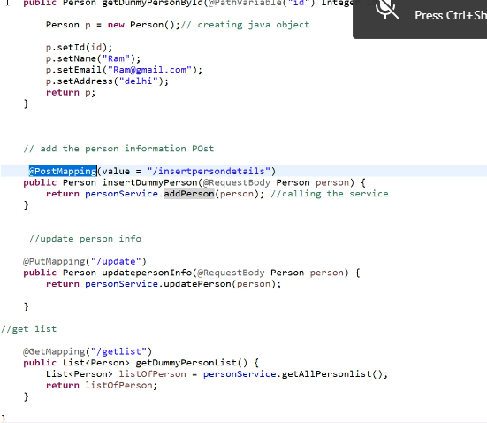

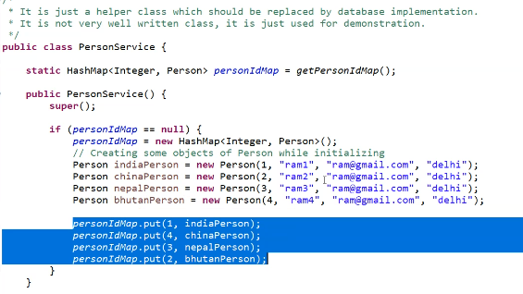

For Person class

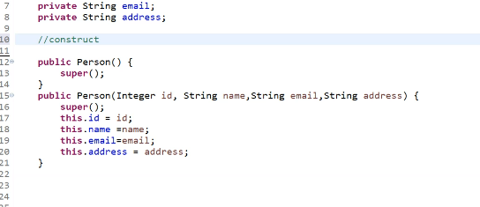

Restdemo

